CSC 122 001 Computer Science II

Julius Ranoa

**Chapter 19 Programming Challenge 8 *Employee Tree***

**Requirements/Objectives of the Challenge:**

Design an *EmployeeInfo* class that holds the following employee information:

Employee ID Number: an integer

Employee Name: a string

Implement a binary tree whose nodes hold an instance of the *EmployeeInfo* class. The nodes should be sorted on the Employee ID number.

Test the binary tree by inserting nodes with the following information: *(Test data included in source code).*

Your program should allow the user to enter an ID number, then search the tree for the number. If the number is found, it should display the employee’s name. If the node is not found, it should display a message indicating so.

**Implementation:**

There are three files included in the submitted project:

1. main.cpp – The driver program. The test data is included here in a function called *loadTestData*.
2. BinaryTree.h – A template implementation for a binary tree. Instead of having objects for the nodes, shared pointers are used. An iterator class is also included, although I couldn’t make it structure it like an STL iterator class due to the difference in structure for binary trees. Note that this implementation of a binary tree is incomplete and is only coded so far as to complete the requirements of the challenge. *(Although, the templating is completely unnecessary.)*
3. EmployeeInfo.h – The header file for the *EmployeeInfo* class, as stated in the requirements. Overloaded functions for the ff. comparison operators: <, >, ==; are added to make the class work with the Binary Tree template.

**Screenshots of Runtime:**

1. With a positive test.  
   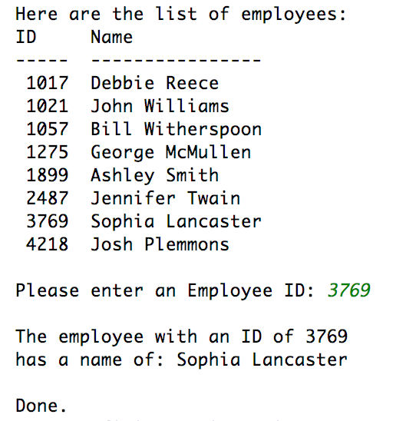
2. With a negative test.  
   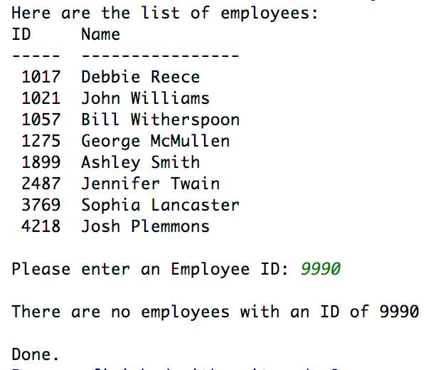

**Source Code for main.cpp**

#include **<iostream>**#include **<iomanip>**#include **"EmployeeInfo.h"**#include **"BinaryTree.h"  
  
void** loadTestData(BinaryTree<EmployeeInfo> &);  
  
**int** main() {  
  
 BinaryTree<EmployeeInfo> EmpList;  
 loadTestData(EmpList);  
  
 *// Display the list of employees.* std::cout << **"Here are the list of employees: \n"**;  
 std::cout << **"ID Name \n"**;  
 std::cout << **"----- ---------------- \n"**;  
  
 BinaryTree<EmployeeInfo>::Iterator i = EmpList.getInOrderIterator();  
 **for** (; i.good(); ++i) {  
 std::cout << std::setw(5) << i->getID() << **" "**;  
 std::cout << i->getName() << **"\n"**;  
 }  
 std::cout << **"\n"**;  
  
 *// Ask the user for an ID:* **unsigned** argID;  
 std::shared_ptr<EmployeeInfo> argInfo = **nullptr**;  
  
 std::cout << **"Please enter an Employee ID: "**;  
 std::cin >> argID;  
 std::cout << **"\n"**;  
 argInfo = EmpList.extract(argID);  
  
 **if** (argInfo) {  
 std::cout << **"The employee with an ID of "** << argID << **"\n"** << **"has a name of: "** << argInfo->getName() << **"\n"**;  
 } **else** {  
 std::cout << **"There are no employees with an ID of "** << argID << **"\n"**;  
 }  
  
 std::cout << **"\nDone."**;  
 **return** 0;  
}  
  
**void** loadTestData(BinaryTree<EmployeeInfo> & BinTree) {  
 *// TEST DATA* **const int** SIZE = 8;  
 **int** EmpIDs[SIZE] = {  
 1021, 1057, 2487, 3769, 1017, 1275, 1899, 4218  
 };  
 std::string EmpNames[SIZE] {  
 **"John Williams"**, **"Bill Witherspoon"**, **"Jennifer Twain"**,  
 **"Sophia Lancaster"**, **"Debbie Reece"**, **"George McMullen"**,  
 **"Ashley Smith"**, **"Josh Plemmons"** };  
  
 **for** (**int** i = 0; i < SIZE; i++) {  
 EmployeeInfo temp(EmpIDs[i], EmpNames[i]);  
 BinTree.insert( temp );  
 }  
};

**Source Code for BinaryTree.h**

#ifndef **CH19_PR8_EMPLOYEE_TREE_BINARYTREE_H**#define **CH19_PR8_EMPLOYEE_TREE_BINARYTREE_H**#include **<memory>** *// For the shared pointers.*#include **<vector>** *// For the iterator.*#include **<iostream>***/*  
 * NOTE: This is a limited implementation of a binary tree class.  
 * Other functions that are not included such as node deletion  
 * were not needed to fulfill the programming challenge.  
 */***template** <**class** T>  
**class** BinaryTree {  
  
**private**:  
 **struct** TreeNode {  
 std::shared_ptr<T> value;  
 TreeNode * left;  
 TreeNode * right;  
  
 TreeNode(  
 std::shared_ptr<T> argValPtr,  
 TreeNode * argLeft = **nullptr**,  
 TreeNode * argRight = **nullptr**) {  
 value = argValPtr;  
 left = argLeft;  
 right = argRight;  
 }  
 };  
 TreeNode * root;  
  
 *// Private Methods* **void** insert(TreeNode * &, std::shared_ptr<T>);  
 **void** destroySubTree(TreeNode *);  
  
**public**:  
 BinaryTree() {  
 root = **nullptr**;  
 }  
 ~BinaryTree() {  
 destroySubTree(root);  
 }  
  
 **bool** search(**const** T, T&) **const**;  
 std::shared_ptr<T> extract(T) **const**;  
 **void** insert(T item);  
  
*// ITERATOR STUFF***public**:  
 */*  
 * NOTE:  
 * A basic iterator is added, just because I wanted to make one.  
 * THIS DOES NOT HAVE THE FULL CAPABILITY OF AN STL ITERATOR.  
 * ONLY THE METHODS NEEDED TO MAKE THE DRIVER PROGRAM RUN ARE ADDED.  
 */* **class** Iterator {  
  
 **private**:  
 std::vector< std::shared_ptr<T> > objPointers;  
 **unsigned** maxIndex;  
 **unsigned** currentIndex;  
  
 *// This function is friended by the Binary Tree class* **void** addPointer(std::shared_ptr<T> newItem) {  
 objPointers.push_back(newItem);  
 maxIndex++;  
 }  
  
 **public**:  
 Iterator() {  
 maxIndex = 0;  
 currentIndex = 0;  
 }  
 **friend class** BinaryTree; *// Allows the binary tree to access the pointer vector.* **bool** good() {  
 **return** ( currentIndex >= 0 ) && ( currentIndex < maxIndex );  
 }  
 std::shared_ptr<T> current() {  
 **if** (currentIndex < maxIndex) {  
 **return** objPointers[currentIndex];  
 } **else** {  
 **return nullptr**;  
 }  
 }  
 **void** reset() {  
 currentIndex = 0;  
 }  
  
 *// Deferencing Operators* T& **operator**\*() {  
 **return** *(objPointers[currentIndex]);  
 }  
 **const** T& **operator**\*() **const** {  
 **return** *(objPointers[currentIndex]);  
 }  
 std::shared_ptr<T> **operator**->() {  
 **return** objPointers[currentIndex];  
 }  
 **const** std::shared_ptr<T> **operator**->() **const** {  
 **return** objPointers[currentIndex];  
 }  
  
 *// Increment Operators* Iterator& **operator**++() {  
 currentIndex++; *// Overflows are handled by current() method* **return** \***this**;  
 }  
 Iterator& **operator**++(**int**) {  
 currentIndex++; *// There's no difference between post and pre  
 // in this implementation.* **return** \***this**;  
 }  
  
 *// Conversion Operators* **operator** std::shared_ptr<T>() **const** {  
 **if** (currentIndex < maxIndex) {  
 **return** objPointers[currentIndex];  
 } **else** {  
 **return nullptr**;  
 }  
 }  
 **operator** T * () **const** {  
 **if** (currentIndex < maxIndex) {  
 **return** objPointers[currentIndex];  
 } **else** {  
 **return nullptr**;  
 }  
 };  
  
 };  
  
*// BinaryTree Iterator Generators***private**:  
 **void** addInOrderIterator(TreeNode * tree, BinaryTree<T>::Iterator & i);  
  
**public**:  
 BinaryTree<T>::Iterator getInOrderIterator() {  
 BinaryTree<T>::Iterator i;  
 addInOrderIterator(root, i);  
 **return** i;  
 }  
  
};  
  
*// Templates  
  
// PRIVATE METHODS***template** <**class** T>  
**void** BinaryTree<T>::insert(TreeNode *& tree, std::shared_ptr<T> newItem) {  
 *// If tree is empty.* **if** (!tree) {  
 tree = **new** TreeNode(newItem);  
 **return**;  
 }  
  
 *// If value is already in tree.* **if** (*tree->value == *newItem) {  
 **return**; *// Do nothing.* }  
  
 **if** (*newItem < *tree->value) {  
 insert(tree->left, newItem);  
 } **else** {  
 insert(tree->right, newItem);  
 }  
  
 **return**;  
}  
  
**template** <**class** T>  
**void** BinaryTree<T>::destroySubTree(TreeNode * tree) {  
 **if** (!tree) **return**;  
 destroySubTree(tree->left);  
 destroySubTree(tree->right);  
 **delete** tree;  
}  
  
*// PUBLIC METHODS***template** <**class** T>  
**bool** BinaryTree<T>::search(**const** T searchTerm, T & itemContainer) **const** {  
 TreeNode * tree = root;  
 **while** (tree) {  
 **if** (*(tree->value) == searchTerm) {  
 itemContainer = tree->value;  
 **return true**;  
 } **else if** (searchTerm < tree->value) {  
 tree = tree->left;  
 } **else** {  
 tree = tree->right;  
 }  
 }  
 **return false**;  
}  
  
  
**template** <**class** T>  
std::shared_ptr<T> BinaryTree<T>::extract(**const** T searchTerm) **const** {  
 TreeNode * tree = root;  
 **while** (tree) {  
 **if** (searchTerm == *(tree->value)) {  
 **return** tree->value;  
 } **else if** (searchTerm < *(tree->value)) {  
 tree = tree->left;  
 } **else** {  
 tree = tree->right;  
 }  
 }  
 **return nullptr**;  
}  
  
**template** <**class** T>  
**void** BinaryTree<T>::insert(T item) {  
 insert(root, std::make_shared<T>(item));  
}  
  
*// BinaryTree Iterator Generator -- Implementation***template** <**class** T>  
**void** BinaryTree<T>::addInOrderIterator(TreeNode * tree, BinaryTree<T>::Iterator & i) {  
 **if** (tree) {  
 addInOrderIterator(tree->left, i);  
 i.addPointer(tree->value);  
 addInOrderIterator(tree->right, i);  
 }  
}  
  
#endif *//CH19_PR8_EMPLOYEE_TREE_BINARYTREE_H*

**Source Code for EmployeeInfo.h**

#ifndef **CH19_PR8_EMPLOYEE_TREE_EMPLOYEEINFO_H**#define **CH19_PR8_EMPLOYEE_TREE_EMPLOYEEINFO_H**#include **<string>**#include **<iostream>  
  
class** EmployeeInfo {  
  
**private**:  
 **int** EmpID;  
 std::string EmpName;  
  
**public**:  
 EmployeeInfo() {  
 EmpID = 0;  
 EmpName = **""**;  
 }  
 EmployeeInfo(**int** id, std::string name = **""**) {  
 EmpID = id;  
 EmpName = name;  
 }  
 **int** getID() **const** {  
 **return** EmpID;  
 }  
 std::string getName() **const** {  
 **return** EmpName;  
 }  
  
};  
  
*/*  
 * The following functions are made assuming that each employee  
 * will have a unique ID and that two EmployeeInfo objects  
 * with the same ID refer to the same employee.  
 *  
 * THESE ARE HERE JUST TO MAKE THE CLASS WORK WITH THE BINARY TREE.  
 * I couldn't make the BinaryTree template to accept a  
 * function pointer as argument with the == operator as the default.  
 * This is the next best thing.  
 */***inline bool operator**< (**const** EmployeeInfo &lhs, **const** EmployeeInfo &rhs) {  
 **return** ( lhs.getID() < rhs.getID() );  
}  
  
**inline bool operator**> (**const** EmployeeInfo &lhs, **const** EmployeeInfo &rhs) {  
 **return** ( lhs.getID() > rhs.getID() );  
}  
  
**inline bool operator**== (**const** EmployeeInfo &lhs, **const** EmployeeInfo &rhs) {  
 **return** ( lhs.getID() == rhs.getID() );  
}  
  
#endif *//CH19_PR8_EMPLOYEE_TREE_EMPLOYEEINFO_H*